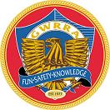

GWRRA Chapter PA- H Northeast Region B August 2010
ATTENTION!!! Our Gatherings are held on the third Sunday of each month at the Mifflinville Fire Hall, Market Street, Mifflinville. Take I-80 Exit 242 to Mifflinville & proceed to the War Memorial on Main Street. Turn Right and go a little over a block. The Fire Hall is on the left. We hope to see you there!

CALENDAR OF EVENTS

August 2010

1st – Picnic Ride to R.B. Winter State Park
5th-7th – NY/NJ Districts Rally
11th – Staff Mtg.
15th – Gathering
15th – Buffalo Valley Pig Roast (after Gathering)
26th-28th – PA District Rally
29th – Mifflinville Fire Co. Ride

September 2010

12th - Gerry’s Mystery Ride
15th – Staff Meeting
17th-19th – All Chapters West (Host: PA-N)
19th – Gathering

October 2010

10th – Fall Foliage Ride
13th – Staff Mtg.
17th – Gathering

November 2010

17th – Staff Meeting
21st – Gathering

December 2010

4th – Christmas Party

WEB SITES

GWRRA
21423 North 11th Avenue
Phoenix, AZ 85027
www.gwrra.org
800-843-9460

Family Membership Cards
Jim Hodge, Executive Director
(228) 875-1764
E-mail: rallybum@cableone.net

Northeast Region B Web Site
http://www.gwrra-northeastregion.org

PA District Website
http://www.gwrrapadist.org/

Chapter H Web Site
(TBA)

District Downloads Page

http://gotomra.com/gwrra/

DIRECTORS’ NOTES

Dear Fellow Wingers,

Let's begin discussing how we think we're two steps ahead, then find out we're three steps behind. After a call from Bonnie a few minutes ago I thought I'd sent my [Glennie’s article] in weeks ago. As I've heard it said before, "It doesn't pay to think". So forward we go!
Summer is more than half over. Speaking for us we've had a very mobile season so far, for those who haven't heard. We traveled to California, New Mexico, Georgia, New Hampshire, Vermont, Maine and New York. Terry turned over 100,000 miles on his bike somewhere out west. He's had it going on 4 years [I think]. Quite an event! We're looking forward to the next few weeks going to the New York/ New Jersey convention as well as our state rally. We are also taking the youngest granddaughter on an adventure somewhere for 3 to 4 days for her birthday present [was in May]. We're trying to instill the gift of travel for her young life instead of material things. The only advice we have to people of all ages is "go while you can and enjoy each day". Memories last a lifetime!
We've been visiting other chapters with hopes of capturing the lead for "Roll for the Dough". Anyone interested in participating, please do. The more, the merrier!" We always have a good time.
Our riding season so far hasn't yielded any really "close calls". We don't know what to attribute it to, or maybe it's a combination of several things. Could it be lights, chrome, awareness, skills, education, wearing bright colors [bright green]; or a combination of all those things? You make the choices.

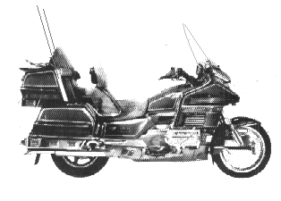

On Wings and A Prayer

Terry and Glennie Payne
Directors Chapter "H"

ACDC
(Assistant Chapter Directors’ Comments)

Hello Riders

Another month has come and gone as the summer flies by. It’s hard to believe its August already and this month is going to be even busier than July. July ended with All Chapters East in Carlisle and Chapter H had 10 members there on Saturday (2 more points). Sunday August 1st was going to be a picnic ride to R. B. Winter Park, but just like last year it rained. So this year rather than cancel, 8 of us had an ”Indoor Picnic” at Friendly’s and the rain didn’t bother us a-bit.
This week on Thursday several of us we be going to the NY/NJ Bi-State rally (2 more points) for the weekend and returning home Sunday. Bonnie and I will be home for a day to repack the trailer, clean the bike, and take off for Myrtle Beach on Tuesday where we will spend the rest of the week with our Kids and Grandkids. On Saturday we will spend a long day in the saddle hurrying all the way home so we can make it to our Gathering and the Buffalo Valley Pig Roast on Sunday the 15th. Then on Thursday August 26th the Pa District Rally starts and we are hoping for a good turn-out (2 more points). It’s always fun to see old friends and make new ones at the Rally. As you can see August is a very busy month, lots of riding and lots of FUN.
In our quest for “Roll for the Dough” points we (Chapter H) are still in second place and should have at least 16 points by the end of this month. That means we need to pick up at least 4 more points in September so we can reach the 20 point milestone. We will then have one more month to visit some other Chapter’s events to get those last few points before the game deadline (Oct 31st).
Have a Great Month, Ride Safe, and let’s have Lots of Fun.

Wind & Wings
It’s All About the Ride!!!

Gerry & Bonnie VanArt
Assistant Chapter Directors

July Gathering/Picnic

On July 14th we had our Gathering/Picnic at the Bloomsburg Town Park at 6pm. There were 18 present. After having a great meal we had our gathering. Thanks for all that you did Gerry and Bonnie to make it a great picnic. Gerry did the cooking of the hamburgers and hot dogs. And thanks to all of the rest of us that brought the picnic foods that make it great.
We had a very short gathering, Gerry wished all those that were having a birthday and anniversary Best Wishes. If you were sick or injured a Get Well.
National News: Wing Ding is past and looking forward to next year’s in Knoxville TN. Mike and Helen Hoover were the only ones from our chapter that went to it.
Region News: The New England Rally will be on July 22-24. We have 4 couples and our District Directors going together on a nice sightseeing tour on the way there. Bi-State Rally will be on August 5-7 in Bridgewater NJ. I know of 4 couples going to that rally.
District News: Our rally will be held on Aug 26-28 in Johnstown, PA. There will be an All Chapters East on the July 29-Aug 1. We have 6 people going down on Saturday the 31st. All Chapters West will be in September. Gerry and Bonnie are going out and staying over night. You may contact them if you have any questions.
Chapter News: We are in second place for the Roll for the Dough. With are rallies that we will be attending and the All Chapters we will be a lot closer to the20 points needed. On Aug 1st we will have a picnic ride. Gerry will send emails out. There will be no staff meeting in August. August gathering will be on the 16th at the Mifflinville Fire Hall at 8 am for breakfast and 9am for the gathering. This will be followed up by a ride to the Buffalo Valley Pig Roast.
We had no 50/50.

Respectfully submitted by
Charlene Knecht, Secretary

New England Rally
On the 16th of July four couples started their travel to the New England rally in Gorham, New Hampshire. Of course there is no straight line to get there. We traveled through Lake Placid, New York, Swanton, Vermont, south to Newport, Rhode Island then north again to Bar Harbor, Maine before we finally rode to Gorham, New Hampshire on the 22nd of July. We also met up with Terry and Glennie Payne at Gorham.
The rally was held at the Town and Country Inn. We had inside as well as outside vendors. Rides were held to look for moose, one had an ice cream stop in it, 4 rides to try on your own, along with the great Mt Washington and it’s unpredictable weather to visit.
They had a Crash Response Scene for us to watch. The police, Fire Company, ambulance and the DART helicopter all participated. It was a good learning experience. Of course we had the Light parade not too many in it but we were escorted by the police and a ride down through town.
Saturday dinner had the awards for all. The farthest traveled was by someone from Utah. Most registered from outside New England was Pennsylvania with 71. Largest Chapter outside of New England was NOT NJ F Troop. It was our own PA Chapter R. PA finally beat them.
Gerry VanArt won for the light show. That makes the second time. The last one was at the Bi-State rally. Hopefully he will win next week in NJ.
Next year’s Rally will be hosted by Connecticut in Maine.
Our four couples woke to rain on Sunday but it moved away fast so we started in the clear. It was a quick trip home all on Sunday. Terry and Glennie headed north for a few more days.

Submitted by,
Charlene Knecht, Secretary

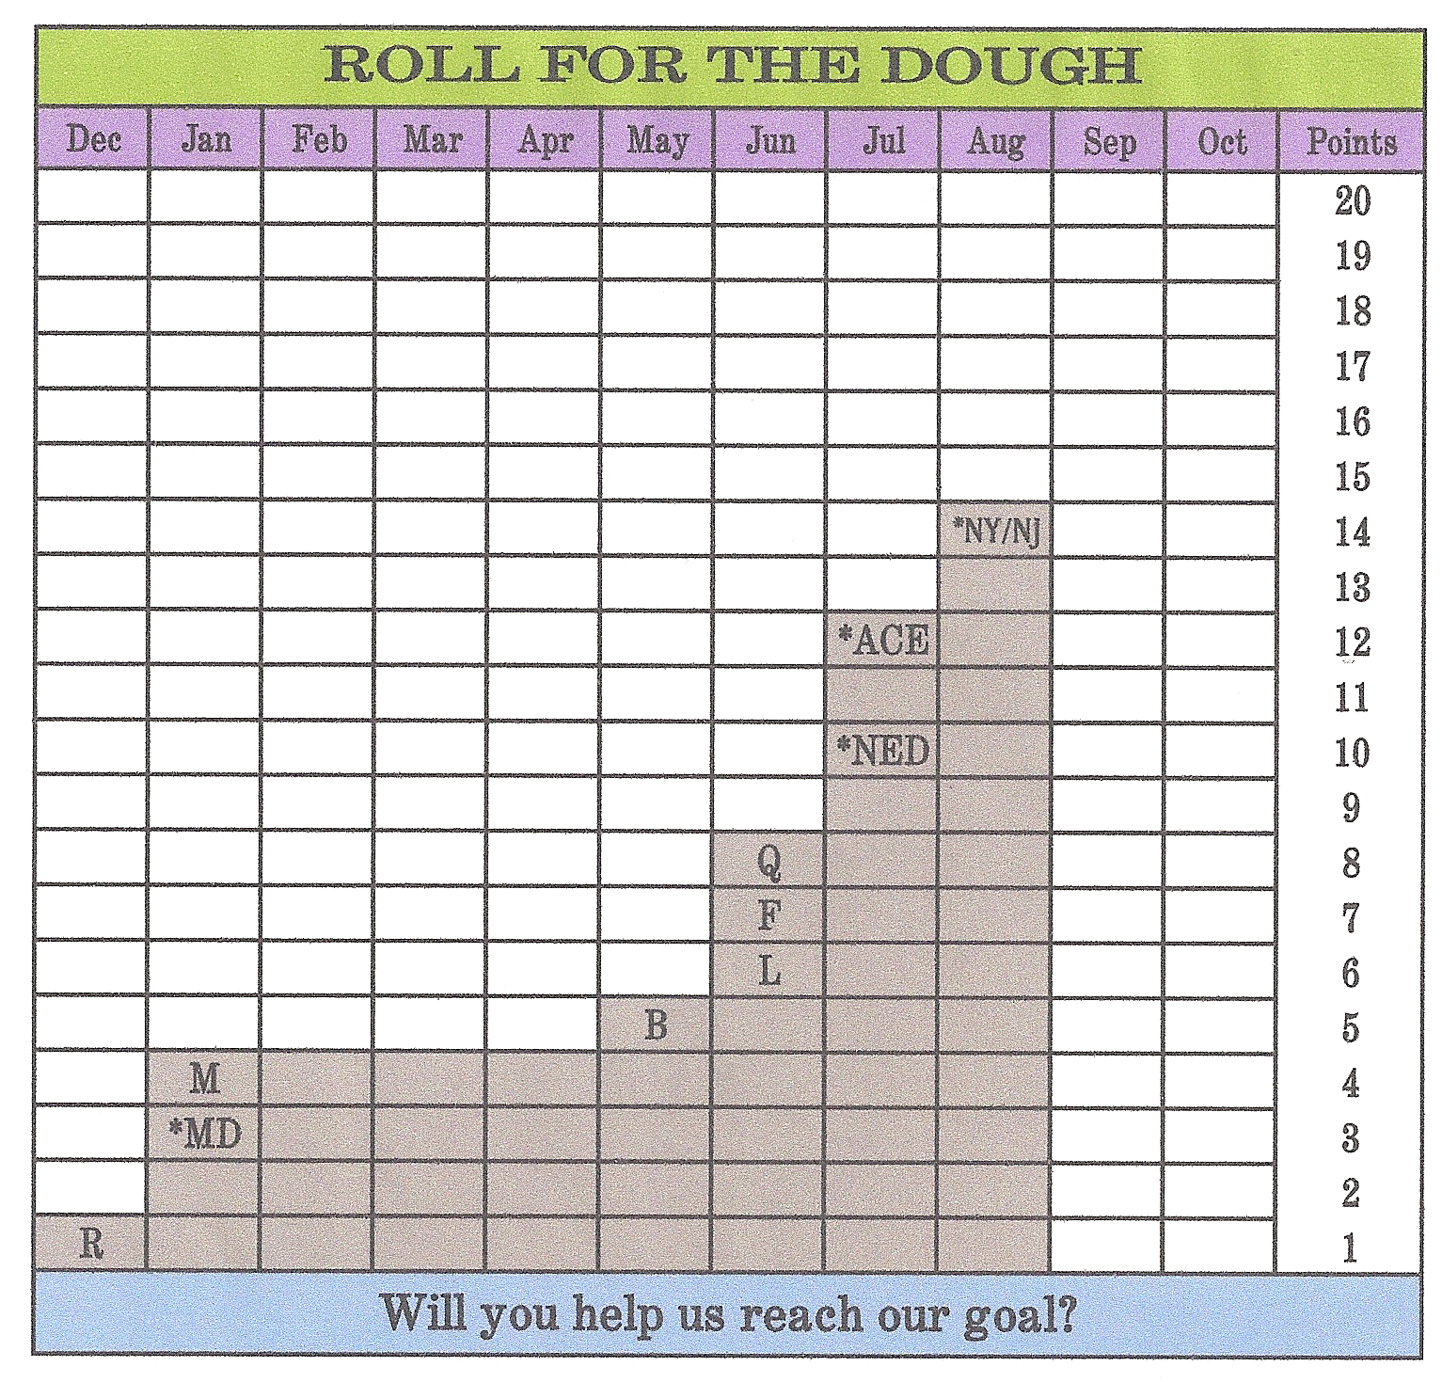
This chart is a record of the points acquired by Chapter H in our quest for the Roll for the Dough District challenge game. We get 1 point for visiting another Chapter and 2 points for attending any District Event in Region B and Pa All Chapters East and West. It takes the attendance of 6 Chapter members to get the points. So far we have 12 points from attending Winter Thing (2 points), 6 different Chapters R, M, B, L, F, and Q (1 point each), New England Districts Convention (2 Points), All Chapters East (2 Points) and New York/ New Jersey Rally . Over the next several months we have the opportunity to acquire many additional points. We will be attending the Pa Rally, All Chapters West, as well as several other Chapters. Keep an eye on the Newsletter and your e-mail for dates and details as they get closer. The FUN starts with the RIDE to the event and continues by Socializing with our GWRRA Friends. So let’s all have some FUN and see how many visits (points) we can get!!!

All Chapters East

On July 31st eleven Chapter H members went down to Carlisle to the All Chapters East. We left Berwick Giant at 7:30 am and had breakfast at exit 100 off Interstate 81. Had a bit of a slow down on the interstate but still made it down a little after 11am. When we got there it was good to see that Betty and Jim Williams had also made the trip. So we had 12 members for our picture for The Roll for the Dough.
We had a nice lunch and time to visit with other chapters. Games were available to play and a Chinese Auction was held in the afternoon. I won one of the prizes. Soon it was time for the supper and we all rode to the dining hall. After a very good supper they had announcements and the 50/50.
We traveled back on I-81 till we came to the Marysville exit, and then took Route 11 the rest of the way home. Of course no ride is complete without the ice cream stop. Hunter’s was the place this time. We all made it home in good time.

Submitted respectfully,
Charlene Knecht, Secretary

Four Harley’s and a Winger
Our trip to Nova Scotia was a unique experience. The weather was very comfortable for riding except for the two days of rain that we encountered while sightseeing Cape Breton. Coming back home was hot as usual. This would be a nice ride to take in the Fall.
If anything could go wrong it did with Dave1. We rode with two Dave’s. First he got a flat tire and we had to wait for the tow trailer, then we had to change our motel. His trailer wouldn’t fit on the truck so we had to unhook one trailer at the motel and go back for his. It was time for dinner. Dave 2 didn’t have a co-rider so Julie rode with him after the guys had to give him a push (because he had a dead battery.) What to do with Dave 1? Well they emptied out one of the trailers and he climbed inside. If you could have seen the looks on peoples faces when he kept lifting the top and then got out. Actually someone in the group got it all on video. One lady went around the block twice and eyes were popping out of their sockets. We had a lot of laughs.
When we got to the restaurant it was closed. Closed restaurants happened a lot on this trip. The bike was ready to go the next day. It was a small town and someone at the motel knew the Yamaha dealer. He came Sunday night to open the shop and put the bike in. He had one tire with a black rim so that’s what went on. It cost $335. If he went to a Harley Dealer it would have been over $5oo and someone in our group would have had to go to Sydney and bring it back, a two hour trip one way. Next he lost the screw from his helmet and someone compromised his credit card.
One big difference between Wingers and Harley’s is that they stop a lot for breaks and not necessarily bathroom breaks. They like their snacks. They also like to stop at Harley shops. We visited five. We also stopped at a lot of signs to have our pictures taken.
I had my first ride on a Harley. I decided I wanted to see the floating boardwalk. It was further than I realized. I was having trouble making it back so Bob came to pick me up. It definitely was different riding one.
When we got home I asked Tony to check our charges and sure enough someone also got a hold of our number. They charged a little less than $ 400 and three smaller amounts. We had it taken care of immediately. We now try to remember to clear the gas pump after we are done.
Ann & Tony
DISTRICT NEWS

We just can’t believe it is August already. We have been really busy planning for the upcoming convention at Johnstown. Believe it or not we have also been working on finalizing a contract for 2011 and working on a location for 2012.
Since we attended our daughters wedding during the 4th of July weekend we were unable to attend Wing Ding this year. Heard that it was a big success and went well. Next years Wing Ding is going to be held in Knoxville Tennessee. Plans are already in the works to make it next year. Hope to see you there. Maybe a chapter of the year???
Not being able to go to Wing Ding had us thinking about somewhere we have never been before. We decided to attend the New England Convention, touring the New England states, before the convention started. With three other couples from Chapter H we set out to see some of the states we have never been to. At the end of our trip we were able to attach a few more of those little diamond stones on our map of states our Goldwing has been.
Our first day was a short trip to Oneonta NY. Stopped here specifically to make sure we could eat dinner at Brooks Barbeque. Funny how trips are planned around places to eat! The second day put us touring through some of the most beautiful roads in NY going through Lake Placid and ending up in Swanton VT. This part of the trip was a little less exciting since we had a little mishap. Seems as though that saying you always hear after a motorcycle accident “I did not see you/them” was said again once more. As we were getting ready to leave a gas station a couple pulled up along side of us and was looking at the trike. We smiled and waved to them and they waved back. We pulled forward to the exit area of the lot waiting for traffic to go by. While waiting, the couple must have decided that they needed gas and started to back up to move to the pumps. Guess the driver was not watching were he was going because he back right up into our trailer. The impact almost pushed us out into the street, with traffic coming at us. Damage was minimal except where the trailer hitch on the truck struck the side of the trailer. As I got off of the trike and approached the driver, the first words I heard were those you seem to always hear after an accident, “ I didn’t see you.” We got all of the insurance information exchanged so that we could get on our way. The trailer was still drivable.
Our third travel day took us to Newport RI. We spent the night so that the next day we could tour some of the mansions in Newport. It is amazing to see the work that was done to these homes during the era that they were built. Lucky we used the town’s transportation system to go from mansion to mansion because it really rained between moving from one to another.
After leaving Newport we traveled more beautiful roads to Bar Harbor ME. Again we used the town’s transportation system to go into town for dinner. What else is there to do other then to make sure you get to eat some of the best lobster that Maine could offer. We spent the night in a motel in which our room was about the size of our bathroom in our house. Even with that, the motel was extremely clean and the owners were very friendly. That made the stay worthwhile. If you get a chance ask Renee about how well the air conditioner worked! The next day we went touring through Arcadia National Park, had lunch at Jordan’s Pond, and went up to the top of Cadillac Mountain. Great view! We had to cut the park tour short because we had reservations on one of the whale watching tour boats. The four-hour trip out on the ocean was well worth the money spent. We got to see five different whales. The humpback was putting on a great show around the boat. The only bad point during the trip out was there were several people around us that could not handle the motion of the boat. Don’t think we need to say more.
We all left Bar Harbor and headed to the New England convention in Gorham NH. Had a good time during the convention. This was a time to meet up with old friends and make new ones. It was also a time for us to sit back and enjoy the convention without worrying about what was going on. That’s going to change in a few weeks!
Congratulations Pennsylvania for being the largest District in attendance, and to Chapter R for being the largest chapter outside the NE England states. Those Roll for the Dough points are adding up!
Now we headed home only to find out that one of the power plants I work at had went down because of a problem. I had to get back to work and working 16-hour days made me miss All Chapters East. Renee was able to attend.
Chapter K did a great job with All Chapter East. Just goes to prove you can accomplish a lot working together. It was a very relaxing day, watching people play the games, catching up with friends, and of course snacking. Saturday night’s dinner was great. The center always does a great job with it.
Thank you again, chapter K for all the time and effort you put into make this a successful event.
There will be a change in location for the Pennsylvania District Convention in 2011. We will announce the location and dates at the closing ceremonies in Johnstown.
The economy has had a big affect on each and every one of us. The District convention and the sales of the District Raffle tickets are not immune to this problem. Registration for this year’s convention is at an all time low. Sales of the District raffle tickets is down, with only 53% of the tickets returned to us sold. All of this considered we have been doing our best to put on a convention that you will still be able to enjoy. We can only work with the funds that all of you help to make. It is extremely hard to plan over a year in advance not knowing if the funds will be available. With only three weeks till the convention we have been making changes so that at the end of the convention we will be able to pay the bills.
Putting the convention issues aside, please remember that we will be supporting the Johnstown Food Pantry again this year. If the economy has had any affect on you, just imagine what kind of affect it has on the people that have been struggling to keep their families fed. If each and every one of us could bring something the Food Pantry can use, as household size non-perishable food items, any paper products and baby supplies. There will be fewer of us at the convention this year so if All of you that will be attending could help; we want to make the collection of food for the food pantry a success.
We’re sure you will find changes once you get to the convention this year. Make sure you check your packet for a new up dated schedule of events. We will try to have a bulletin board located in the registration area to list any changes that have been made to that day’s event. There will be changes in the Rider Education seminars, Leadership Training seminars, new events associated with this year’s theme and Pennsylvania will be hosting the Region Couple of the Year Selection.
All Chapter Directors have received their Chapter Assignment for the Convention in the packets at the District Staff Meeting, so check with him/her to see how you can help.
We will need help and participation from ALL CHAPTERS. This is the only way our Rally will be a success and everyone can enjoy it. SO REMEMBER WHEN SOMEONE ASKS YOU TO HELP JUST SAY “YES”.
The Convention Registration form has been sent out to all the Chapter Directors, Assistant Directors, and appears on the PA web page. The pre-registration date has passed but it is still not too late to register for the convention.
All Saturday Day Pass with Banquet will have until the August 20th deadline to register. If you registered for this you will have to come to the registration table to pick up your packet on Saturday.
Don’t forget that Friday night, we are having a talent show. Miguel Lebron & Gracie Tirado, the District Couple will be in charge of this event. If you would like to entertain the membership, or simply show off your talents, please contact them at gwrra.pa.districcouple2010@gmail.com We need all of your help to make this event a success. We cannot do it without you.
During Friday nights Talent Show we would like to have a best dressed Clown contest. Plan on dressing up as a clown when you come to the talent show and you could be the lucky winner of a first or second place prize for the best-dressed clown. There will be no official judging because the judges will be mixed in with the attendees of the talent show and could even be dressed as a clown just like you.
Remember, the hospitality room will be open to everyone who comes to the rally. If you come on a full registration or a day pass you are welcome to stop in the hospitality room. With this being said, remind everyone that is coming to the convention to help keep the hospitality room supplied with snacks by bring something to share with their fellow members. We have promised the Pasquerilla Center all food and drinks will stay in the hospitality room.
Chapter Directors and Assistant Chapter Directors look over the schedule for the convention. There will be a question & answer seminar about the Couple of the Year program on Friday. This seminar is for you to ask questions about the program and see how important it is for your chapter. There maybe some changes made for the 2011-year and it would be nice if you were on the same page as all of the chapters when it comes to the COY program. We believe this program is very important for the chapters to be involved in. This seminar may help you with getting a couple to become your Couple of the Year.
LIGHT PARADE:
For many years, Gary Dunn sponsored our light parade and kept it going. Please, plan on riding in the parade on Thursday night, so we may all pay a tribute to someone who had done so much to keep this tradition alive! Come out and ride with us in the light parade even if you don’t have any other lights then what the wing comes with.
We have received premission from the Johnstown City Manager to make a second loop from Point Stadium to the War Memorial. As long as there are no emergencys in the city the police department will cooperate with us.

BIKE SHOW:
There will be changes in the bike show this year. Classifications and judging all taking place on Saturday. Classifications are planned to start at 9am and go to 11:30am. Judging, as of right now, is planned for 1pm to 2:30pm. A Saturday day pass will permit you to enter the bike show. Depending on the convention schedule these times are subject to change. Be sure to check your packets when you arrive at the convention.
RALLY RAFFLE TICKETS:
WE REALLY NEED YOUR HELP WITH GETTING THE DISTRICT RAFFLE TICKETS SOLD!
Please turn in any sold tickets to your assistant district directors.
The deadline for your Chapter to receive credit for selling the tickets is fast approaching. It is August 10th.
UP COMING EVENTS:
ALL CHAPTERS WEST hosted by Chapter N on September 17th & 18th, 2010. Location is the Kozy Rest Kampgrounds in Harrisville, Pa.
PENNSYLVANIA DISTRICT CONVENTION, August 26th, 27th and 28th in Johnstown, Pa.

Tom & Renee Wasluck
Pennsylvania District Directors
570-474-1014
goldwing@ptd.net

Ride safe, have fun

SAFETY FIRST

A Bomb In Your Luggage
The odds are higher than you think
By: James R. Davis

My guess is that about half of the motorcycles on the road that have luggage compartments are carrying a highly inflammable if not outright explosive 'tool' somewhere in those bags. Not black powder. Not gasoline. Not plastique. It's usually called WD-40! This is a wonder product of amazingly useful application. It is also prone to turning into a fireball when exposed to spark or fire or a lit cigarette.
The manufacturer, I'm told, has recently begun packaging WD-40 using one of two different propellants - one of them remains hydrocarbon based and highly flammable, the other is not. You need to read the package closely to find out which one you have in your saddlebags, but the vast majority are the more flammable variety.
By the way, for those of you who have chain drives, the last place in the world you want to spray WD-40 is on your chain! It is a DEgreaser, after all.

Copyright © 1992-2006 by The Master Strategy Group, all rights reserved.
http://www.msgroup.org

(James R. Davis is a recognized expert witness in the fields of Motorcycle Safety/Dynamics.)

Sick Bay

Larry Faupel, PA-W Chapter Director was diagnosed with leukemia,. He will be undergoing some intense radiation. We know Larry and Ellen could use some prayers and words of encouragement. Cards can be sent to Larry at:
299 Sleek Road
New Paris, Pa 15554

Condolences

Note from Randy Cheesman
Director Chapter PA-A

Barb Dunn's father, Robert Berry, passed away recently. He was 86 years old and suffered from extensive cancer. He was in the hospital at the time and waiting to go home with hospice care as Gary (PA-A) did. He and his wife were staying with Barb for the last eight months. Condolences can be sent to Barb at:
Barb Dunn
70 Eagle Court
Gilbertsville, PA 19525
610-369-3688
barbcdunn@comcast.net
We at Chapter PA-H sincerely express our sympathy to Barb and her family. She’s gone through a lot this year, and our hearts go out to her.

I’d like to remind everyone to please submit articles you have for the newsletter by August 31st for the September newsletter. Remember, this is your newsletter, and it’s only as good as you make it. Please contribute information to it.
Also, as always, I’m open for any comments, suggestions, or questions. I’m truly grateful to all of you who submit articles. Without your input there would be no newsletter.

Bonnie VanArt, Editor
PO Box 513
Mifflinville, PA 18631-0513
Phone: (570) 759-9304
Cell: (570) 764-1280
E-Mail: gbvanart@msn.com

FOR SALE

***New Frogg Toggs rain gear at reduced prices for sale. Also will sew patches on vests. See Chuck Russo for more information or call: 570-458-5938

2003 Illusion Blue Honda Goldwing - $17,500 includes Trailer
• 27027 miles – Beautiful Show Bike - Garaged kept
• Customized Lighting Blue w/ red accent Boogey lights, night rider, owls eye & custom fork lights
• Chrome wheels
• Non Fancy Pin striping (single color, very subtle)
• Tulsa Windshield with Extra Large Eagle etching and custom LED lighting
• Chrome Valve Covers w/ Emblem Set, Chrome Timing Cover (not stick-ons)
• Chrome Lower Cowl and Fog Lights customized LED Trunk and Saddlebag , Chrome Molding
• Numerous Chrome Accessories - too many to mention
• Custom Diamond seat, back rest and passenger bag
• Passenger audio controller
• Highway pegs and Passenger Adjustable Footrests
• 2 Arai Helmets and 2 Shoei Helmets – color matched
• CB Radio. Trunk Lighted Mirror, Customized Interior Trunk Lighting
• Bushtec Chrome Front Fender Extension
• Trunk Spoiler and Lower Trunk Spoiler – both color matched
• Rear Speakers
• Progressive Shocks
• Passenger Armrests & Butler Cup / Holder
• Wired for (2) Gerbings heated gear sets
• Garmin GPS Mount
• Luggage rack w/ beehive risers (not mounted on bike) & Luggage Rack Bag
• GoldWing Trunk & Saddle Bag mats
• Color matched dash
• Owners manual
• Mechanics manual
• 2 Bike covers, 1 windshield cover, dash cover to match seat
** All original parts replaced with custom or chrome parts are included**

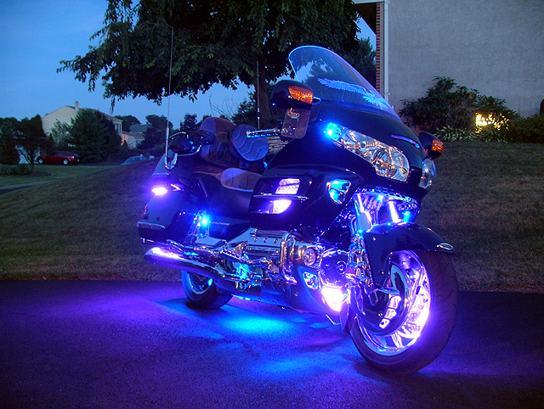

2003 Escapade Trailer – Illusion Blue (color-matched–11 ,000 mi.)
• Spoiler
• Chrome wheels
• Completely lined interior
• Spare Tire
• Garment bag
• Cooler with cover
• Trailer Cover
• Bra
For more information and pictures, email Barbara Dunn barbcdunn@comast.net or call (610)369-3688

Note: “For Sale” items will be displayed in this newsletter for three consecutive months unless I am informed otherwise. If the item is sold, please let me know, so I can remove the ad. Please send “For Sale” Information to me at gbvanart@msn.com

COOK’S CORNER

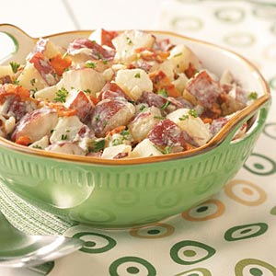
Bacon Potato Salad Recipe

Ingredients
- 4 cups cubed red potatoes
- 1 cup chopped onion
- 7 bacon strips, cooked and crumbled
- 2 tablespoons minced fresh parsley
- 1-1/3 cups mayonnaise
- 3 tablespoons grated Parmesan cheese
- 3 tablespoons prepared ranch salad dressing
- 2 tablespoons prepared mustard
- 4 teaspoons white vinegar
- 1/2 teaspoon minced garlic
- 1/4 teaspoon salt
- 1/4 teaspoon pepper

Directions
- Place potatoes in a large saucepan and cover with water. Bring to a boil. Reduce heat; cover and cook for 10-15 minutes or until tender. Drain.
In a large bowl, combine the potatoes, onion, bacon and parsley. In a small bowl, combine the remaining ingredients. Pour over potato mixture; toss to coat. Refrigerate for 1 hour
Please!! We need your recipes for cook’s corner, so put on your thinking caps and see what you can come up with. What are some of your favorite recipes? Perhaps you could share them with us! If so, submit them to me, Bonnie VanArt, at:
PO Box 513
Mifflinville, PA 18631
Email: gbvanart@msn.com

HAPPY BIRTHDAY!

August 3rd – Dean Jordan
August 6th – Steve Snyder
August 21st – Holly Gray
August 24th – Glennie Payne
August 24th – Arden Strouse
August 31st – Cindy Garrison

September 2nd - Tina Michael
September 9th – Donna Phillips
September 10th – Charlene Knecht
September 23rd – Charlie Milbrand

HAPPY ANNIVERSARY!

August 9th
Bill & Esther Cleaver

August 12th
Bob & Peggy Swank

August 16th
Paul & Lani Brenner

September 12th
Mike & Helen Hoover
