Chapter X Directors
Rick & Carol Rodgers (570) 587-2531 card@epix.net
Treasurer
Marianne DeStefano
Chapter 2008 COY
Web Master
Newsletter Editor
Chapter Educator
Tom Bridgen
Chapter Store
Jan Paylor (570) 836-5285 jep624@hotmail.com
MED Co-coordinators
Phil & Jan Paylor (570) 836-5285 jep624@hotmail.com
Cheer Committee
Bill & Mary Jane Williams (570) 378-2102
Regional & District
Northeast Region Directors
Lorraine & Earl Knight
PA District Directors
Chuck & Evelyn Stone
PA Asst. Directors
NE Tom & Renee Wasluk (570) 474-1014
PA District Rider Educator
Mae Welker (570) 265-8331
PA District Trainers
John & Bonnie McClun
2008 PA District COY
2008 NE Regional COY

A HUG IS THE PERFECT GIFT, ONE SIZE FITS ALL
AND NO ONE MINDS IF YOU EXCHANGE IT !!

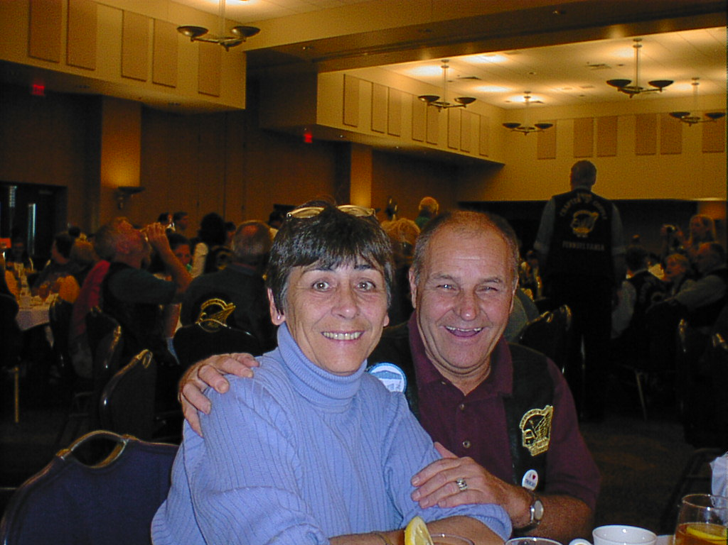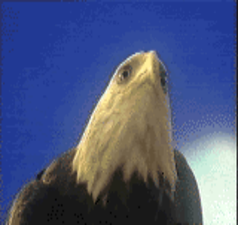

AMERICA, STAND BESIDE HER…

CHAPTER DIRECTORS CORNER:

By now everyone’s bike or scooter has been put away for
the season and we are thinking,” if I only lived where it
was warm all year”. But alas we do not, so let us think about the many things that we are so lucky to have in the Land of the Free and the Home of the Brave.
Think of all those who gave their all so we could have all that we do. When you send out Christmas cards this year, make sure you send one to some one in the Armed Forces. Here is an address you can use.
A Recovering American Soldier
C/O Walter Reed Army Medical Center
6900 Georgia Ave, NW
Washington, D. C. 20307-5001

Happy Holidays: Carol and Rick

NEXT CHAPTER GATHERING:

CHAPTER X GATHERING:
We meet the third Sunday of the month at PERKINS on RT 6 Tunkhannock, PA
Breakfast at 9:00 AM , Gathering at 10:00 AM.
DISTRICT DIRECTOR:
"THE STONE AGE"
FROM YOUR DISTRICT DIRECTOR:
Hi everyone:
Fall has arrived; the leaves have changed and with the wind and snow we have received in the last week they are starting to fall. The time has changed and the days are getting shorter. On the bright side we still have the thrill of Fall Foliage Rides to look forward to but make sure you do it safely. Be aware of changing conditions such as reduced traction due to the falling leaves and in the morning reduce visibility due to early morning fog.
DISTRICT STAFF MEETING:
NOTICE TO ALL CHAPTER DIRECTORS AND ASSISTANT CHAPTER DIRECTORS:
PLESE MARK YOUR CALENDARS, OUR 2009 DISTRICT STAFF MEETING WILL BE HELD ON MARCH 21st, 2009. IT IS “EXPECTED” THAT EVERY CHAPTER WILL BE REPRESENTED AT THIS VERY IMPORTANT MEETING. The District Staff Meeting will again be held at the Arena Restaurant in Bedford, PA and as in the past you can pick the motel of your choice for lodging. As many of you are aware the Quality Inn is located adjacent to the Arena Restaurant. A Friday evening social will be held in the BEDFORD Room from 7:30 p.m. – 8:30 p.m. for those of you who want to sit around and visit with
your GWRRA friends. Please bring a snack and the District will have water and coffee available to
drink. Our meeting will be held on Saturday morning in the HERITAGE A-D Banquet Room at the Arena
Restaurant and begin promptly at 8:00 a.m. The District Staff will be staying at the Quality Inn-Bedford, which has rooms available at a rate of $64.99 for singles or doubles. The phone number to
make reservations is (814) 623-5188. There are many other motels/hotels in the Bedford area so contact your favorite and make your reservations early.
Just a reminder the Chapter can cover the costs incurred by the Officers in attending this VERY
IMPORTANT meeting.
KEYSTONE STATE RALLY: Planning for the 2009 Keystone State Rally is almost complete and as in years past we will be looking for help and participation from ALL CHAPTERS. This is the only way our Rally will be a success and everyone can enjoy it. SO REMEMBER WHEN SOMEONE ASKS YOU TO HELP JUST SAY “YES”. The Rally Registration form is presently a work in progress and will be sent to out to all the Chapter Directors, Assistant Directors, and appear on the PA web page as well as being included in next months newsletter as soon as it is completed. Just a reminder that again this year as last year “TO COMPETE IN ANY RALLY EVENT, YOU MUST BE FULLY REGISTERED FOR THE
RALLY “, EX: Bike Show, Light Show, Chapter Competitions, Hospitality Room and COY Competition.
<NO FULL REGISTRATIONS WILL BE SOLD AT THE RALLY>
Register early and avoid the rush. You should have received your new listing of Hotels/Motels and Campgrounds in the Johnstown area. These have been sent out to the Chapter Directors, Assistant Directors, and appear on the PA web page as well as being included in the newsletter.
RALLY RAFFLE TICKETS:
This year our fundraiser will again be a “CASH BONANZA” with 40 chances to win. There will be (2) $1,000.00 winners, (2) $500.00 winners, (4) $250.00 winners, (10) $100.00 winners and (22)
$50.00 winners. The tickets have been mailed to the Chapter Directors who should IMMEDIATELY distribute them to EVERY member of the Chapter. This is the only way the tickets will be sold. There is no reason why EVERY CHAPTER cannot sell all 200 tickets if they put the same effort into selling
the District Tickets that they do in raising money for other charities.
THE TICKETS WILL NOT SELL THEMSELVES IN THE DIRECTORS BRIEF CASE.
NOTE TO ALL CHAPTER DIRECTORS: IF YOU DELEGATE THE BRESPOSIBILITY, FOR
DISTRIBUTING THE TICKETS AND THE FOLLOWING UP TO MAKE SURE THEY ARE BEING SOLD, TO ANOTHER CHAPTER MEMBER, YOU ARE STILL RESPONSIBLE FOR THE OUTCOME.
The tickets will sell for $5.00 each and we are asking ALL the chapters to support this fundraiser for 2009. In addition, 50% of the net profits will be divided among the 24 chapters based on the number of
tickets each sold to do with as they see fit. So the more tickets the chapter sells the bigger their
percent of return in the final distribution.
NEW RALLY LOGO FOR 2009:
We are looking for a New Rally Logo that will be displayed on the Rally Shirts. The theme for the 2009 Rally will be “THE STONE AGE RETURNS TO BEDROCK”. So get those thinking caps on and work on
designing that perfect “THE STONE AGE RETURNS TO BEDROCK” logo, that all will be wearing next August in Johnstown. The winning entry will receive a cash prize of $50.00, which will be presented at the District Rally Banquet, in Johnstown, on August 22, 2009. Last year we had (8) entries, so your challenge for this year is to at least double that amount of entries. We all know the GWRRA Talent that is out there so let’s see it. LOGOS MUST BE SUBMITTED TO US BY “DECEMBER 5th, 2008”.
RALLY AD BOOK:
It’s not too early to get your Chapters Ad for the Rally Ad Book into Diane Heffelfinger. A Flier will be included in the next District Newsletter and posted on the Web site. The prices are the same as last year, $75.00 for a Full Page, $40.00 for a Half page and $25.00 for a Business Card size AD. Last year we had 100% participation by the Chapters and are expecting to do the same in 2009.
SOMEONE SPECIAL AWARD:
Do not forget to submit your nomination for the SOMEONE SPECIAL AWARD. Nominations are to be submitted to us no later than July 17. There are many deserving individuals out there, so please take a few minutes and submit that individual’s story to be considered for the Someone Special Award. We should receive entries from every Chapter.
The next Horizon’s Leadership Training will be held at the New Holland Middle School, New Holland, PA on November 8th & 9th. There are still some spots available, so don’t delay; contact John and Bonnie McClun, PA District Trainers, to reserve your spot in the class.
PA ALL CHAPTERS – EAST (formally known as BXLAZY) will be hosted by Chapter “H” in 2009. The location and dates will be announced soon.
PA ALL CHAPTERS – WEST (formally known as PA ALL CHAPTERS) will be hosted by Chapter “G” in 2009 and will be held in Erie. Please mark your calendar for July 24th & 25th, 2009. More information on this event will follow in January.
YEAR END PAPERWORK:
Those chapters who are changing officers should be contacting your Assistant District Director to get the necessary paperwork started.
YEAR END FINANCIAL PAPERWORK:
The year End Financial Reports are due to your Assistant District Director so that they can have them to us in Everett, PA by January 15th. We will then forward them to Region so that they can have them to National by February 1st. National would like to calculate how much money GWRRA “gives back” in the form of charitable donations at the local, state and national level. In order to do this they are asking that all financial reports ENTER AN ESTIMATE OF HOW MUCH MONEY IS RAISED AND GIVEN TO ANY CHARITY. If you would write in the amount on the TOP OF THE FINANCIAL COVER SHEET, that would be most appreciated.
EVERYONE’S REMEMBER: When everyone helps a little no one has to do a lot.
“Ride Safe & Ride Proud”
Chuck & Evelyn Stone
PA-District Directors

NE-ASSISTANT DISTRICT DIRECTORS :
There is nothing like living in North East Pennsylvania in the wintertime. We had to remind ourselves of that when we woke up to snow today. October 28 and we got about 3” of snow. Amazing!!! Sunday it was 60 out and we were trying to get thing s done around the house so we could go on a bike ride. Just goes to prove, you never know what to expect in this area when winter really does arrive.
First, we would like to thank all of our chapters that have gotten their Charter Fees to us. As of today, we have received 5 out of 6. We have also received the officers change paperwork from the chapters with changes. Thanks again to all of you! We won’t be spending our holiday season trying to get
that done.
We have started to visit our chapters this month. We attended Chapter H’s gathering. Afterwards,
Buddy Thompson gave a great refresher course on group riding. Yes, most of us have been around awhile and have heard it all. But these classes are very important for everyone’s safety. You never know what you might have forgotten, or you just might learn something new.
We did take a weekend ride to view the fall foliage. We left on Saturday morning, and found just about every off the beaten path back road possible in upstate New York. It was incredibility beautiful. Then we headed into Massachusetts where we spent the night, then enjoyed a beautiful ride through
Rhode Island and Connecticut before returning home on Sunday.
This past weekend, we headed out to Chapter M. They have moved to the Williamsport Airport. The
food was good; the meeting place is great, with room to grow, and the friendship even better.
Beginning November, we will start visiting all the chapters to promote all the Fun events at the 2009
Rally in Johnstown. After much thought, And Chuck and Evelyn’s approval, we have finally figured out all of the events for Friday. They will include:
The Stone Capades
Prehistoric Pets Parade
Flintstone Flyer Attire
Details will be following in the next few weeks. Also keep the West End Food Pantry in mind for the rally. Chuck and Evelyn have sent out the Raffle Tickets—they make great Christmas gifts.
We will be putting all this nasty weather behind us for a week, as we set sail for the Bahamas, St Thomas, and St Martin. Hopefully the weather here will warm up a little when we get back.
Be safe and stay warm
Happy Thanksgiving to all.
Tom and Renee Wasluck
NE Pa Assistant District Directors

FROM YOUR PA DISTRICT RIDER EDUCATOR:
Hello to All,
Don't know where the year has gone. Time seems to just pass us by too fast. The weather has really been great for some last rides. But, it won't last for long, so have you been thinking of winter maintenance for your bike? Just had mine gone over, with necessary things done, after summers riding. Now, that Fall was definitely here, I was a bit surprised that mice had been in my garage, and decided that they should make a nest in the air cleaner. Since, I knew it needed changed, anyway. Now, to keep the little devils from doing more, it has been said to put moth balls around places near and on the bike. Also, dryer sheets tucked in places will help too. This I was not aware of. I did put moth balls around last year, but apparently not enough. Also, if you happen to keep bird seed in your garage, mice or
something, likes to stash that in your air cleaner as well.
Our trusted, and dependable cycle mechanic is coming to 'R' chapter gathering this month to give us tips on winter maintenance. Need to learn all we can, or at least be reminded. So with that, enjoy what rides we have left.
Have a SAFE and Happy Thanksgiving

Be Safe, Mae
PA DISTRICT MED COORDINATORS:
“MENBERSHIP ENHANCEMENT”
Happy Fall to all. We know you are all out there taking advantage of the beautiful riding weather.
Just remember the leaves are starting to fall and can cause some problems, please be aware. Mother
Nature has been real good to us this month but things are starting to chill down and we need to
remember that we will need to dress a little warmer. The rallies are behind us, now is the time when the anniversary and holiday parties begin. This is a great time to visit other Chapters and keep those cold weather blues at bay. As you all know MED is the fun part of GWRRA. If you don’t have a MED person in you Chapter, now is a good time to get one. They will help the CD’s plan event, help out with the Couple of the Year, lend a hand with recruiting & retention and commutations. What I’m trying to say , a MED
person on the staff, is a great help for the Chapter and the Chapter Director. Put one on YOUR staff, you won’t regret it.
Please Ride Safe and God Bless.
Ruth & Mort Smith
Pa. District MED Coordinators
“We are Listening, What is Your Solution”

CHAPTER X EDUCATOR:
Modulator Background:
In the early 1970s came a tremendous surge in motorcycle sales. The reasons are many: A generation of "baby-boomers" had reached legal driving age; the first OPEC oil embargo and the subsequent gasoline shortage made travel by motorcycle much more economical than driving a car; the Japanese motorcycle manufacturers were challenging the domestic American and British manufacturers for cycle supremacy and gaining rapidly as the British manufacturers -- Triumph, BSA, Norton, et.al. were losing their market (and survival) to the competition. The 70s surge in motorcycle sales was followed by a whole lot of auto-motorcycle collisions. Analyses of the events leading to collisions, such as "The Hurt Study" on the cause of the accident rate increase showed that all these new motorcyclists were essentially "invisible" to other motorists, mostly in automobiles. In an effort to help the motorcyclist become more visible on the road, many states passed mandatory lights-on laws. Headlamps were required to be turned on whenever the cycle was in operation. Lighted headlamps provided a decrease in the number of auto-cycle collisions and fatalities. In the 1980s, many motorcycles (primarily the Japanese) were manufactured with the headlight switch either electrically defeated or eliminated altogether. The headlamp would constantly be lighted whenever the engine was running, by design. This improved the cyclist's visibility to the other vehicles in front of him without any action whatsoever on the part of the cyclist.
Since having one's headlights on improves vehicle head-on recognition to other vehicles (and because the inept public lacks the common sense to turn on headlights during dawn/dusk, fog, rain, snow, smoke and other poor-visibility conditions) some automobile manufacturers, and most notably General Motors, began installing Daytime Running Lights - DRLs - as standard equipment on their autos. DRLs automatically operate the auto's high-beam lamps at reduced voltage (less brightness) whenever the ignition switch is on, with NO operator action... which is a good idea to make cars more visible in reduced-visibility situations, but is a bad idea for motorcyclists who then lost their safety edge from having their lights on all the time. Now with the common use of DRLs, a motorcycle could be lost in a "sea" of turned-on headlights during daylight conditions. Something was needed to make the motorcycle stand out from the crowd once again. Enter the 1990s and development of the motorcycle headlight modulator. With a modulator installed, the motorcyclist is once again able to be differentiated from other traffic, with the headlight pulsating, varying between two degrees of brightness.
The flickering of the high-beam is unmistakable. Disliked by some, misunderstood by many, it is seen by all. Simply put, MODULATORS GET YOU NOTICED ! And being noticed improves the odds that you'll be seen by an inattentive driver, ergo the chance for a collision with an auto is reduced.
Headlight modulator installation is recommended for the cycle's HIGH beam element, although it is legal on either high or low beam. The reason the high beam is preferred is because the high beam pattern illuminates the area to the center and left of the bike's centerline, which is the direction from which the majority of auto-cycle collisions occur... especially oncoming cars turning left in front of the cycle. The low beam pattern tends to illuminate the area to the center and right of the bike's centerline, a location where fewer auto-cycle collisions seem to originate. A common comment frequently reported in post-accident investigation dialogue is the auto driver saying "I never saw him." Perhaps it's because the driver wasn't looking at the cyclist, or looked "right through" the cyclist, not taking note of his presence. With a headlight modulator operating the high beam of the headlight, there is less potential for that statement to be made.
As I said... MODULATORS GET YOU NOTICED !
An important distinction that you should be aware of if you are considering the purchase of a modulator or defending its use, is that the modulating headlamp DOES NOT FLASH! Flashing is defined as the rapid turning on and turning off of power to the lamp. With a headlight modulator, the lamp never turns off, but rather power is varied between two different power levels at a specific rate of speed. Therefore it does not flash. It simply modulates (or pulsates, shimmers, twinkles or flickers, if you prefer)... Flashing lights are illegal on all but emergency vehicles. But Modulating lights are legal. But keep in mind that they are legal on motorcycles only. Automobiles are not permitted to have modulating headlamps.
Now, lets keep in mind proper etiquette.
Headlight Modulator Etiquette:
While use of a modulator is indeed legal, some common sense should be used while it is in operation. Since it can be switched on and off at will using the headlight dimmer switch, there are times and situations in which it is reasonable and proper to turn it off:
When you are sitting behind a vehicle in traffic, your modulator can be a nuisance to the driver in front of you. This is especially true if you are far enough behind the other vehicle for your headlamp to shine in the driver's rear-view mirror.
When you are sitting at a red traffic light waiting to proceed through the intersection with nothing in front of you to block the light, your modulator may be a nuisance to a driver on the other side of the intersection facing you. Give him a break. Dim your headlight (turn off the modulator) until the traffic light turns green and you can proceed.
If you are going to be stationary behind any vehicle for more than a few minutes, do the driver ahead of you a favor. After following someone for a while, it will become clearly obvious to you that the driver in front has noticed you. Put your headlight on low beam (modulator off) until you prepare to pass the driver.
Turn off your modulator when you are riding in a group, unless you are the lead bike. The lead bike's modulator will stimulate enough of the oncoming driver's attention for the whole group. If you're riding in the "drag" or "sweep" position, you can give the leader an occasional "twinkle" on a long straightaway to let the tour leader know how far back the tail end of the group is, without being an annoyance to the rest of the group. (This applies more to LARGE group rides like Americade's mini-tours, where there may be 50-60+ bikes in the tour group.)
Keep common courtesy in mind. Remember that a modulating high beam can be as much of an assault on one's eyes as loud pipes are on one's ears. Act accordingly. Act responsibly. And remember that the impression you leave on the public reflects on ALL motorcyclists!

Tom Bridgen Chapter Educator

From Your chapter MED Coordinators

SCHEDULE AND DATES OF UPCOMING CHAPTER X ACTIVITIES:

12/14 | X Gathering at Perkins 9:00am

FROM OUR COY:
Well, as most of you know now this will be Vicki and my last gathering as members of chapter X. It’s with a sad heart that we say goodbye. I have come to the realization that riding is too hard and too much of a challenge for me anymore, I get too tired, to sore and I just plain don’t feel well enough to continue. My physical conditions just make it a chore to ride and a danger to us as well as others. We will miss GWRRA, the chapter and especially all of you.
I suspect you will still see our bike around, as Gary Miller has bought it… CONGRATULATIONS Gary and June, I am sure you’ll enjoy the bike… ride her in good health and enjoy her, I know she has found a good and loving home.
We love you guys, ride safe!!
Bill and Vicki Weaver


